**Windows**

Every computer needs an Operating System to function. Microsoft Windows is one of the most popular Graphical User Interface (GUI). Multiple applications can execute simultaneously in Windows, and this is known as “Multitasking”. Windows Operating System uses both Keyboard and mouse as input devices. Mouse is used to interact with Windows by clicking its icons. Keyboard is used to enter alphabets, numerals and special characters.

**Logo:**

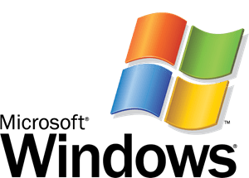

Pros n cons:

Advantages of windows operating system

* Support for all hardware
* Ease of use
* Plug and play feature
* Software support
* Desktop and touch screen

Disadvantages of Windows operating system

* Virus attacks
* Most of the software is paid
* Rebooting a system
* High price
* High computer resources
* Technical support

Linux:

**LINUX** is an operating system or a kernel distributed under an open-source license. Its functionality list is quite like UNIX. The kernel is a program at the heart of the Linux operating system that takes care of fundamental stuff, like letting hardware communicate with software.

Logo:



**Advantages of Linux Operating System**

Cost

Security

Source Code

System Requirements

 System Updates

## Disadvantages of Linux Operating System

Adaptation

Software Compatibility

Gaming

Hardware Compatibility

Technical Support

**Mac**

The Macintosh Operating System (Mac OS) is an operating system (OS) designed by Apple Inc. to be installed and operated on the Apple Macintosh series of computers. Introduced in 1984, it is a graphical user interface (GUI) based OS that has since been released as multiple different versions.

Initially, Mac OS was known as System Software.

**Logo:**

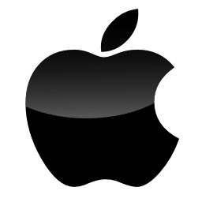

### **Advantages of macOS**

* **Fewer virus attacks:**
* **Good customer support:**
* **Similar GUI for all the products:**
* **Default apps:**
* **Performance and long life:**
* **Support NTFS and FAT:**
* **Can run Windows:**

### **Disadvantages of macOS**

* **Expensive:**
* **No hardware customization:**
* **Fewer games and software:**
* **Windows cannot read the macOS file system:**
* **Less hardware used:**

Android:

Android is an operating system and programming platform developed by Google for mobile phones and other mobile devices, such as tablets. It can run on many different devices from many different manufacturers. Android includes a software development kit (SDK) that helps you write original code and assemble software modules to create apps for Android users. Android also provides a marketplace to distribute apps. All together, Android represents an ecosystem for mobile apps.

Logo:

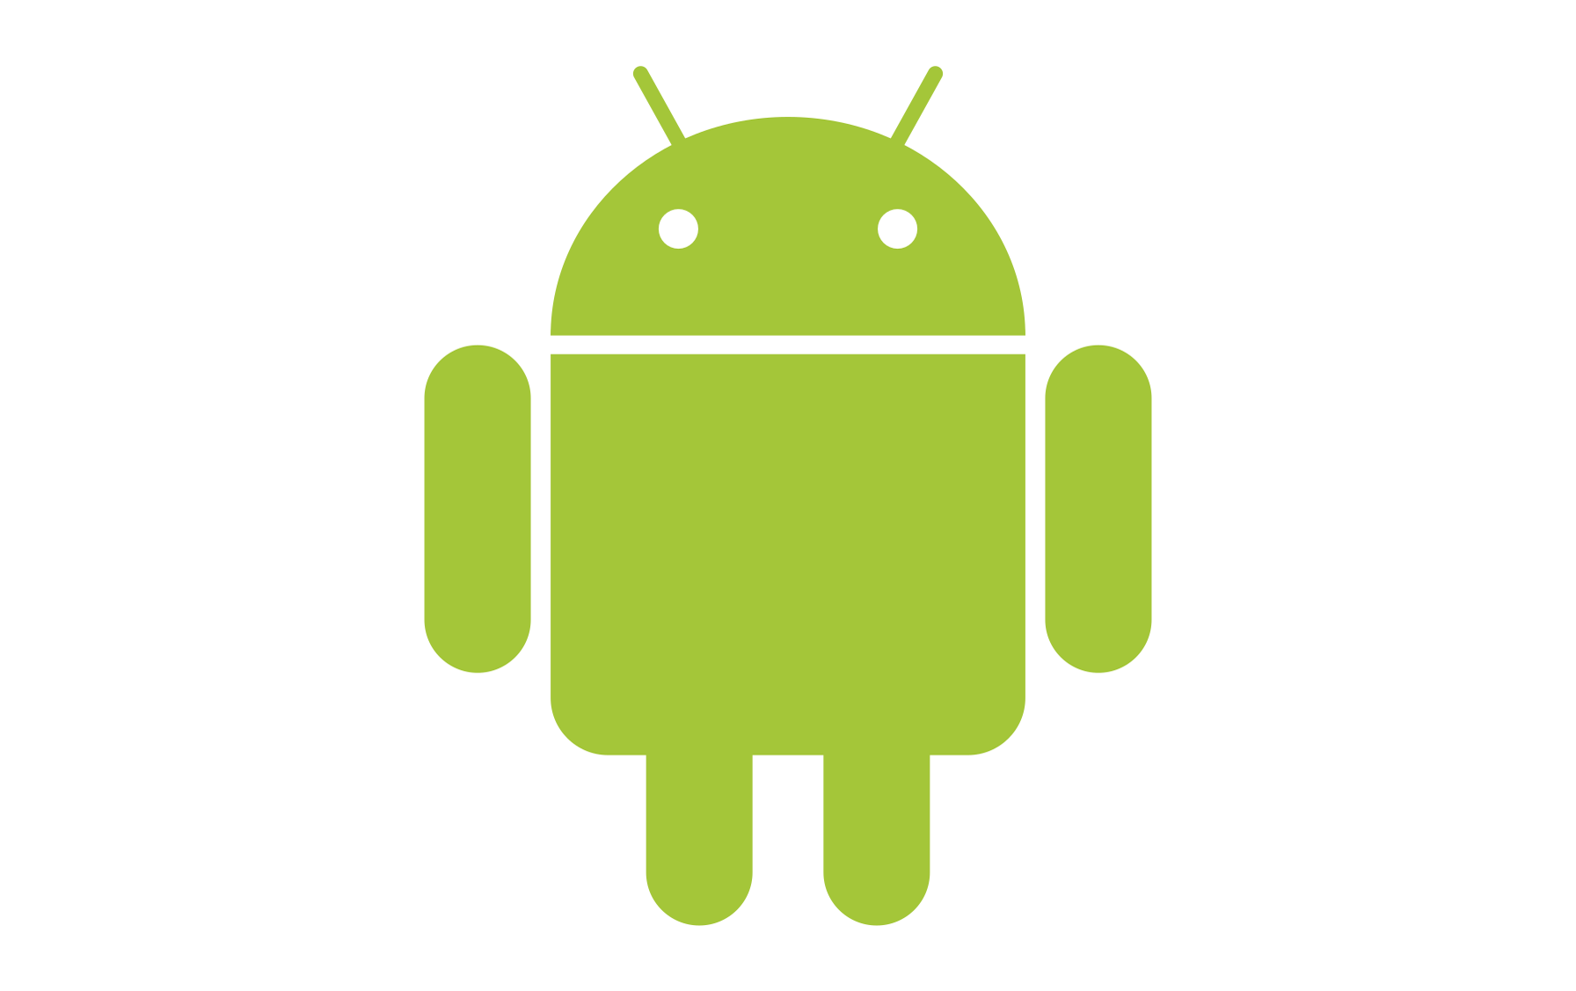

**Advantages of android :**

* Android is totally open because it is a Linux based open source
* Multitasking
* Excellent software support
* It gives you a better notification
* It let you choose your hardware
* It has a better app market
* Frequent OS updated
* A more mature platform
* Android type of phone can also function as a router to share internet
* It will be more secure than i-phone OS
* All application are treated equally
* Easy to access the android app in the market
* Can installed and modify RAM
* An Android-based product will cheaper than its propriety
* Support all google services
* With the google chrome, you can open many windows at once

**Disadvantages of Android :**

* Need internet connection
* Sometimes slow devices
* Wasteful battery
* It requires to continue internet connection
* Generally, power hungry
* Very unstable
* Android market is too much less control of the manager, sometimes there are malware
* Externally in-consistence in design among apps
* No standardization of application quality
* Advertising facility disturb you
* Difficult to modify
* Many application contains a virus
* Android has no standard strategy or upgrades path
* Android application must be written in JAVA

Ios:

[IOS](https://intellipaat.com/blog/tutorial/ios-tutorial/) stands for iPhone operating system. It is a proprietary mobile operating system of Apple for its handheld. It supports Objective-C, C, C++, Swift programming language. It is based on the Macintosh OS X. After Android, it is the world’s second most popular mobile operating system. Many of Apple’s mobile devices, including the iPhone, iPad, and iPod, run on this operating system. To control the device, iOS employs a multi-touch interface, such as sliding your finger across the screen to advance to the next page or pinching your fingers to zoom in or out of the screen.

Logo:



**Advantages of iOS**

* Easy to use:
* **Ideal for app developers:**
* **Gaming:**
* **Heat generation:**
* **Google maps:**
* **Used for business:**
* **Media:**
* **Performance:**
* **Security:**
* **Jailbreaking:**
* **Many apps:**
* **Better camera:**
* **Gestures:**
* **Supports multi-language:**
* **Communication between devices:**
* **Multitasking:**

Disadvantages of iOS

* Same icons:
* **Very simple:**
* **Apps are costly:**
* **Limited devices:**
* **Not open source:**
* **App approval:**
* **No SD card:**
* **Battery timing:**
* **Repairing is expensive:**
* **Supports single sim:**
* **Large apps size:**
* **NFC and radio:**
* **Addictive UI:**
* **Changing ring tunes:**